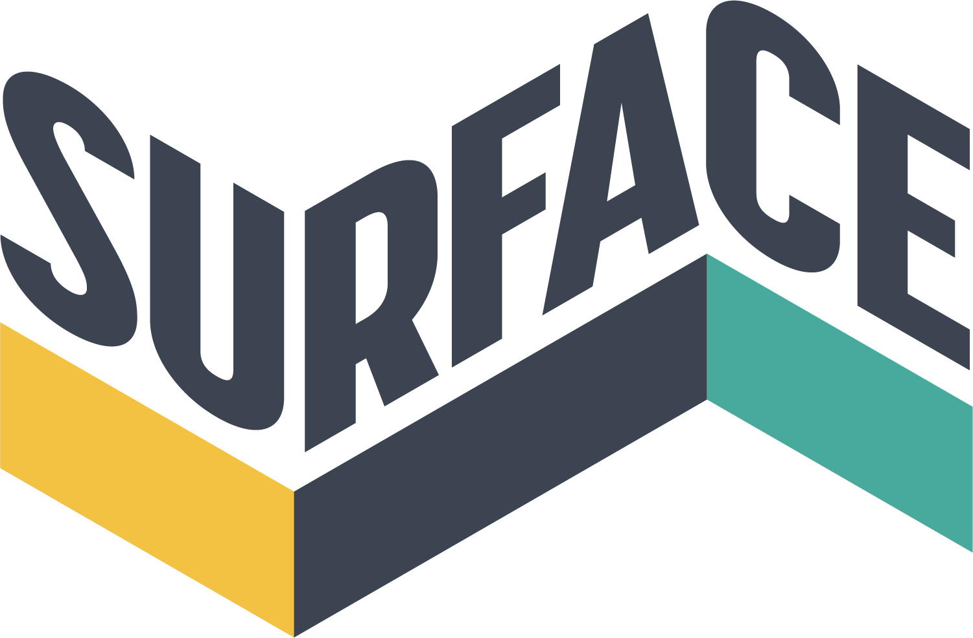

EAST MIDLANDS GRADUATE ARTISTS
Residency and Exhibition Programme 2022
EM 19: Octeria with Wolfgang Buttress

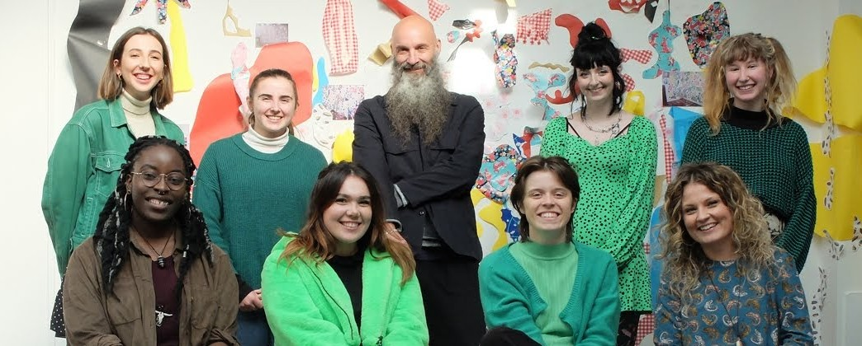

Surface is now accepting submissions for our twelfth East Midlands Graduate Project, EM22: Nottingham’s only graduate residency. This opportunity supports Fine Art graduates from across the region by offering a free residency and exhibition in an independent contemporary art space to kick-start the transition from university to professional art world.

Eight artists will be selected to produce a new body of work for the subsequent exhibition. The residency will take place in our open-plan project space, enabling the artists to interact and develop their practice in a stimulating and mutually supportive environment. There will be in-house critical feedback, and several opportunities for formal critique sessions with established artists and curators.
4TH-19TH NOV
EXHIBITION
RESIDENCY
15TH AUGUST
Midnight
3RD-30TH OCT
APPLICATION DEADLINE

PHOTOS FROM EM19
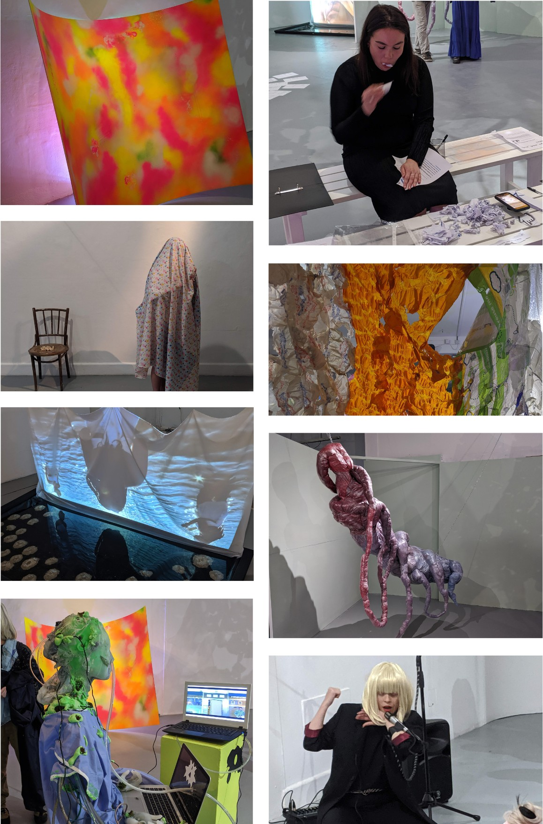

About Surface
Surface is the local contemporary art gallery of Nottingham.
We operate as a social enterprise, celebrating and supporting talent in our city, and engaging with our immediate community with a view to broadening participation in the arts. We are led by a co-operative team of early career professionals, who support each other in order to learn more about running a successful independent art gallery.
Located within Nottingham’s burgeoning Creative Quarter, Surface’s three-storey building welcomes visitors and exhibitors to its two gallery spaces, nine artist studios and open-plan office area.

THE PROJECT WILL INCLUDE
- A four-week artist residency at Surface: a high-quality, large and well-lit working space where artists will have free reign to develop new work.
- A two-week group exhibition at Surface following the end of the residency.
- Support and advice from the Surface team who will provide artistic and technical assistance throughout the residency.
- Networking and Q&A opportunities with the active artist community who work in the building.
- Promotion in the Surface newsletter and extensive social media network.
- 500 flyers distributed across the city to promote the exhibition.
- A potential small commission to help produce a new body of work during the residency. *
- Potential inclusion in a catalogue to document the project. *
- Potential travel expenses. *

THE PROJECT WILL INVOLVE
- Progress meetings – selected artists will discuss the residency’s progress and plan for their exhibition with the support of the Surface team.
- Critique sessions – held during the residency period. The selected artists will meet with established artists to receive feedback on their work.
- Artist talks – taking place during the exhibition and open to the public. Artists can discuss their practice and new work created for exhibition, with the support of Surface.
- Workshops – the opportunity to organise and run workshops with the local community
- Development – opportunities for one-to-one sessions with the Surface team.
- Curating – gain invaluable experience by organising a group exhibition.

*Please note we are in the process of seeking funding for this exhibition. Therefore the specific details of what the project will include will depend on the success of our funding bid

THE PROJECT SCHEDULE
Below is an outline of a proposed schedule. It is intended to give a useful time-scale of deadlines for the selected artists to work towards. The schedule will be finalised in discussion with the selected artists at the initial project meeting.

INITIAL PROJECT MEETING
24th September – an opportunity to meet with the other selected artists and the Surface team.

RESIDENCY BEGINS
3rd October – the selected artists will be invited to move into the gallery space.

PLANNING AND PROGRESS MEETINGS
Week commencing 3rd October Week commencing 10th October Week commencing 17th October
Final progress meeting and review session: 24th October

EXHIBITION SET UP
31^{t} October – 3rd November

EXHIBITION
4th – 19th November

ARTIST TALKS
12th November

ELIGIBILITY TO APPLY | SUBMISSIONS
Applications are welcome from all recent Fine Art graduates from East Midlands universities, but also graduates now resident in the region. The universities within the East Midlands are: | DEADLINE FOR SUBMISSIONS IS MONDAY 15TH AUGUST 2022,  midnight.
NOTTINGHAM TRENT UNIVERSITY UNIVERSITY OF LOUGHBOROUGH LINCOLN UNIVERSITY | Any applications that do not follow the guidelines below or are received after the deadline cannot be considered.
DE MONTFORT UNIVERSITY UNIVERSITY OF DERBY UNIVERSITY OF NORTHAMPTON | Please take into consideration your availability during the project period. We expect good attendance and that the work produced for the exhibition will be made in our Project Space.

Surface Gallery | 16 Southwell Road | Nottingham | NG1 1DL 0115 947 0793 | info@surfacegallery.org | www.surfacegallery.org

East Midlands Graduate Residency & Exhibition 2022
Application Form

ABOUT THE APPLICATION
The deadline for applications is Monday 15th August, 11.59pm.

Return to: info@surfacegallery.org
APPLICATION PROCESS
Residency dates: 3re – 30th October 2022 Exhibition dates: 4th– 19th November 2022.

Application deadline: 15th August 2022, 11.59pm Shortlisted applicants notified: Thursday 18th August Interviews: week commencing 22nd August Successful applicants informed: Tuesday 30th August Residency begins: Monday 3rd October

NAME
HOME ADDRESS

PHONE NUMBER
EMAIL ADDRESS
ARTIST WEBSITE OR BLOG
UNIVERSITY

1 - IMAGES OF YOUR PRACTICE

Please include 5 images of your work (or links to video) in your application. You must name your files to correspond with the list below, e.g. image1_title. Each image file should be no more than 500KB. Large video files (more than 5MB) should be provided on DVD or as a link to Vimeo, YouTube, etc.

Please provide a brief description of each piece in the space below.

IMAGE 1:

IMAGE 2:

IMAGE 3:

IMAGE 4:

IMAGE 5:

2 - AN ARTIST STATEMENT

Please include a recent artist statement (200 words maximum).
Copy and paste in this box below, or attach as a separate document in your email to us with this form.

3 - A SUPPORTING STATEMENT

Please write a statement of no more than 1000 words to include:

- A detailed description of the new work you propose to develop during the month-long residency and ideas you have for how the work would be exhibited in Surface Gallery.

- What are your reasons for wanting to do this project?

- Why do you feel you would be suitable for this project?

4 - AN ARTIST CV

Please include your artist CV as an attachment or as a link online.

We look forward to reading your application, thank you for applying!

